Country: **Lesotho**

Year: **2014**

Number of Observations: **9402**

Number of Clusters: **5**

Number of variables used: **26**

Distance used: **Hamming**

**Variables used in the algorithm:** hv206,hv207,hv208,hv209,hv237,hv243a,hv243b,hv244,hv246,hv247,hv252,sh110b,sh110c,sh110k,water,toilet,floor,roof,cookfuel,wall

**Summary of Top Cluster Configurations (ranked by ASW)**

| **Cluster #** | **ASW** | **Variable 1** | **Variable 2** | **Variable 3** | **Variable 4** |
| --- | --- | --- | --- | --- | --- |
| **1** | 0.880340726344268 | hv206 | hv209 | hv243a | sh110b |
| **2** | 0.878155748497301 | hv206 | hv209 | hv243a | sh110c |
| **3** | 0.875099680288149 | hv206 | hv243a | sh110b | sh110c |
| **4** | 0.872315740003756 | hv243a | sh110b | sh110c | sh110k |
| **5** | 0.864776835971197 | hv206 | hv243a | sh110b | sh110k |
| **6** | 0.864258687815208 | hv237 | hv243a | hv243b | sh110b |
| **7** | 0.863971703240263 | hv243a | hv243b | sh110b | sh110c |
| **8** | 0.862196996855856 | hv237 | hv243a | sh110b | sh110c |
| **9** | 0.861686720070454 | hv206 | hv243a | sh110c | sh110k |
| **10** | 0.860648798235531 | hv209 | hv243a | sh110b | sh110c |

**Distributions of ASW values in all clusters in Lesotho**

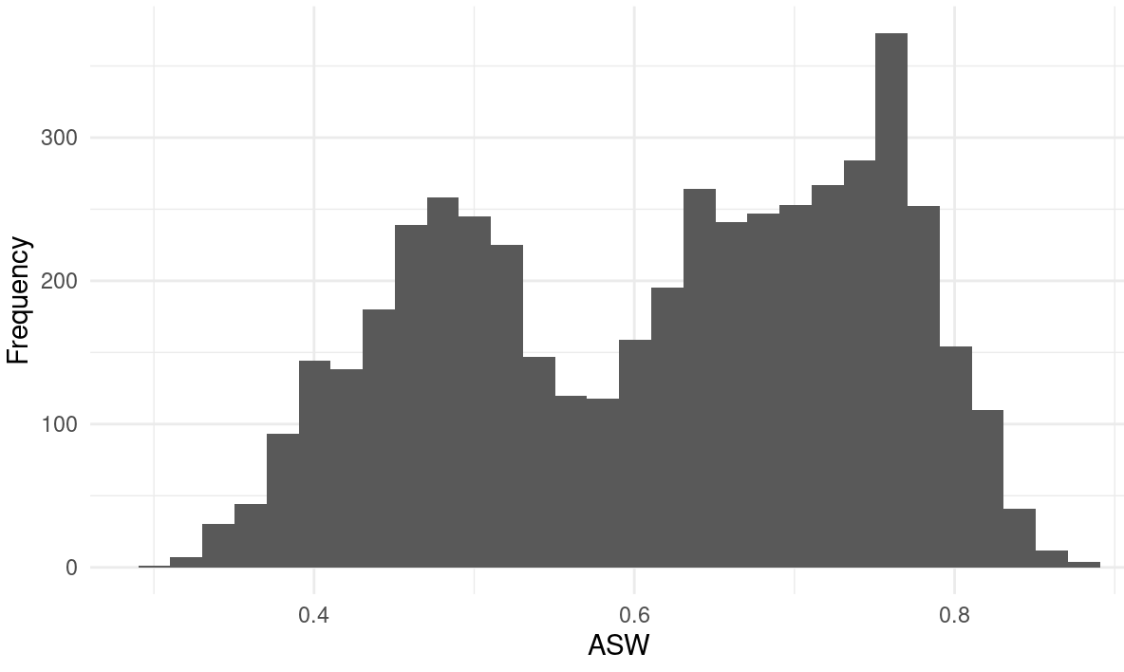

**Summary of variable distributions in top clusters**

Currently our method is choosing five distinct clusters of individuals within each cluster variable configuration. Here are the medioids for each of these five clusters:

**Marginal Distributions**

| Variable | Description | % time in top clusters | Distribution |
| --- | --- | --- | --- |
| hv206 | Has electricity | 50% | Binary,25.9% 1s (or yes) |
| hv209 | Has refrigerator | 30% | Binary,19.9% 1s (or yes) |
| hv237 | Anything done to water to make safe to drink | 20% | Binary,11.2% 1s (or yes) |
| hv243a | Has mobile telephone | 90% | Binary,82.1% 1s (or yes) |
| hv243b | Has watch | 10% | Binary,12.9% 1s (or yes) |
| sh110b | Battery or generator | 80% | Binary,11.1% 1s (or yes) |
| sh110c | Solar panel | 70% | Binary,17.0% 1s (or yes) |
| sh110k | Internet access | 30% | Binary,16.0% 1s (or yes) |

**Cluster #1 Configuration**

| **Config#** | **Node** | **hv246** | **hv246d** | **hv247** | **sh121i** | **Proportion** |
| --- | --- | --- | --- | --- | --- | --- |
| **1** | 1 | 1 | 1 | 0 | 0 | 15.91% |
| **2** | 1 | 1 | 1 | 1 | 0 |
| **3** | 1 | 1 | 1 | 1 | 1 |
| **4** | 2 | 0 | 0 | 1 | 0 | 48.12% |
| **5** | 2 | 0 | 1 | 1 | 0 |
| **6** | 3 | 1 | 0 | 1 | 0 | 8.75% |
| **7** | 4 | 0 | 0 | 0 | 0 | 17.78% |
| **8** | 4 | 0 | 0 | 0 | 1 |
| **9** | 4 | 0 | 1 | 0 | 0 |
| **10** | 4 | 0 | 1 | 0 | 1 |
| **11** | 4 | 1 | 0 | 0 | 0 |
| **12** | 4 | 1 | 0 | 0 | 1 |
| **13** | 5 | 0 | 0 | 1 | 1 | 9.43% |
| **14** | 5 | 0 | 1 | 1 | 1 |
| **15** | 5 | 1 | 0 | 1 | 1 |

**Validation of Top Cluster with Chi-Sq Distribution**

Note that in the tables, the rows are the validation variables, and the columns are the node number from the cluster distributions in the table above.

